
DATA SCIENCE LAB
CYCLE 1


Ashly Joshy
ROLLNO:16,SJCET PALAI

1.Program to Print all non-Prime Numbers in an Interval
CODE:
#Take the input from the user:
lower = int(input("Enter lower range: "))
upper = int(input("Enter upper range: "))
for num in range(lower,upper + 1):
if num > 1:
for i in range(2,num):
if (num % i) == 0:
break
else: print(num)
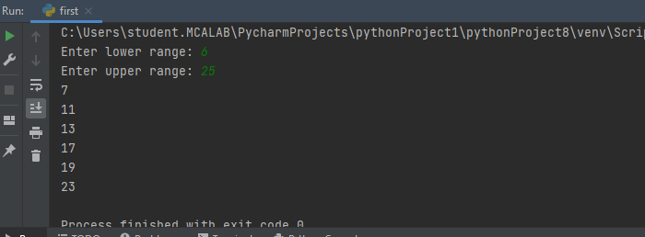
2. Program to print the first N Fibonacci numbers.
CODE:
n = int (input("Enter the number of terms needed in the Fibonacci series: "))
if (n<0):
print ("Enter a positive number")
else:
f1, f2 = 0, 1
if n == 1:
print (f1)
elif n == 2:
print (f1,f2)
else:
print (f1,f2, end = ' ')
for i in range (3, n+1):
f3 = f1 + f2
print (f3, end = ' ')
f1 = f2
f2 = f3
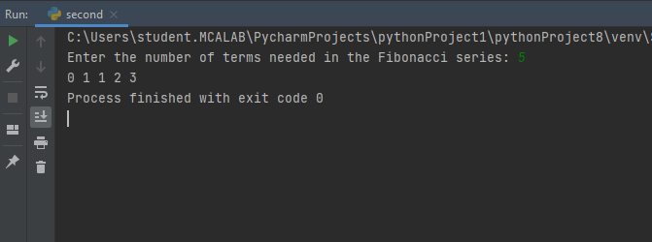

3. Given sides of a triangle, write a program to check whether given triangle is anisosceles, equilateral or scalene.
CODE:
print("Input lengths of the triangle sides: ")
x = int(input("x: "))
y = int(input("y: "))
z = int(input("z: "))

if x == y == z:
print("Equilateral triangle")
elif x==y or y==z or z==x:
print("isosceles triangle")
else:
print("Scalene triangle")
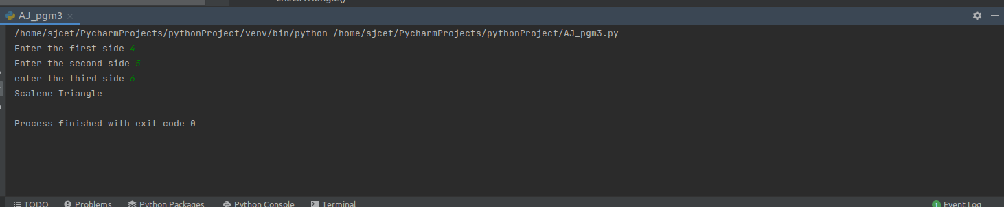

4. Program to check whether given pair of number is coprime
CODE: def are_coprime(a,b):
hcf = 1
for i in range(1, a+1):
if a%i==0 and b%i==0:
hcf = i
return hcf == 1
# Reading two numbers
first = int(input('Enter first number: '))
second = int(input('Enter second number: '))
if are_coprime(first, second):
print('%d and %d are CO-PRIME' %(first, second))
else:
print('%d and %d are NOT CO-PRIME' %(first, second))

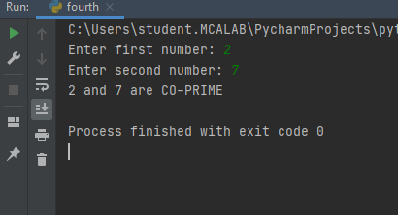
5. Program to find the roots of a quadratic equation(rounded to 2 decimal places)
CODE:
from math import sqrt

print("Quadratic function : (a * x^2) + b*x + c")
a = float(input("a: "))
b = float(input("b: "))
c = float(input("c: "))

r = b**2 - 4*a*c

if r > 0:
num_roots = 2
x1 = (((-b) + sqrt(r))/(2*a))
x2 = (((-b) - sqrt(r))/(2*a))
print("There are 2 roots: %f and %f" % (x1, x2))
elif r == 0:
num_roots = 1
x = (-b) / 2*a
print("There is one root: ", x)
else:
num_roots = 0
print("No roots, discriminant < 0.")
exit()
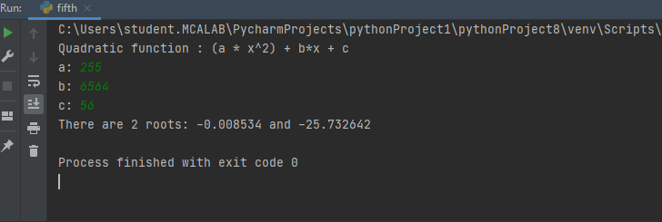

6. Program to check whether a given number is perfect number or not(sum of factors
=number)
CODE:
n = int(input("Enter any number: "))
sum1 = 0
for i in range(1, n):
if(n % i == 0):
sum1 = sum1 + i
if (sum1 == n):
print("The number is a Perfect number!")
else:
print("The number is not a Perfect number!")
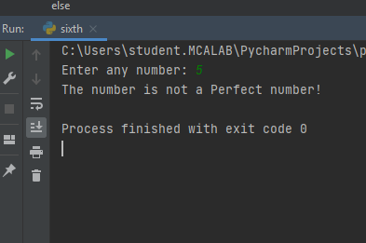
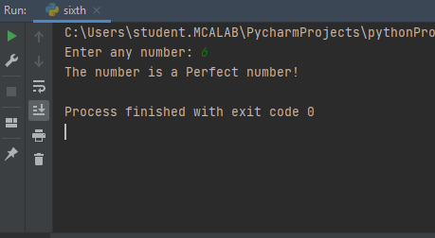

7. Program to display amstrong numbers upto 1000
CODE:
lower = int(input("Enter lower range: "))
upper = int(input("Enter upper range: "))

for num in range(lower,upper + 1):
sum = 0
temp = num
while temp > 0:
digit = temp % 10
sum += digit ** 3
temp //= 10
if num == sum:
print(num)
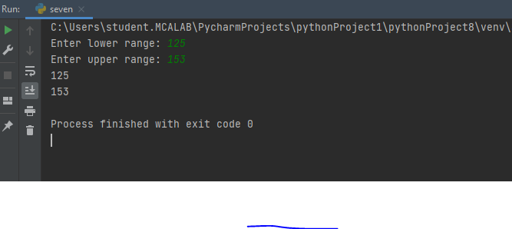

8. Store and display the days of a week as a List, Tuple, Dictionary, Set. Alsodemonstrate different ways to store values in each of them. Display its type also.
CODE:
list = ["Sun","Mon","Tue","Wed","Thu","Fri","Sat"]
print(type(list))
print(list)
tuple = ("Sun","Mon","Tue","Wed","Thu","Fri","Sat")
print(type(tuple))
print(tuple)
set = {"Sun","Mon","Tue","Wed","Thu","Fri","Sat"}
print(type(set))
print(set)
dict = {
"d1" : "Sun",
"d2" : "Mon",
"d3" : "Tue",
"d4" : "Wed",
"d5" : "Thu",
"d6" : "Fri",
"d7" : "Sat"
}
print(type(dict))
print(dict)
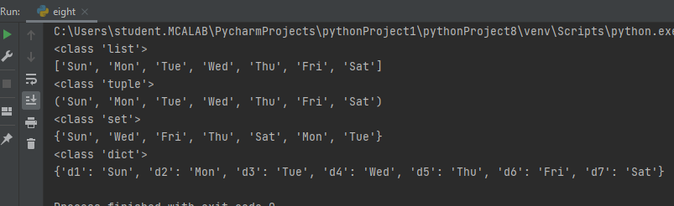

9. Write a program to add elements of given 2 lists
CODE:
# initialize the Python lists
lt1 = [5, 10, 15, 20, 25, 30]
lt2 = [2, 4, 6, 8, 10, 12]

# print the original list element
print ( " Python Original list 1: " + str (lt1))
print ( "Python Original list 2: " + str (lt2))

# use naive method to add two list.
res_lt = [] # declaration of the list
for x in range (0, len (lt1)):
res_lt.append( lt1[x] + lt2[x])
# Display the sum of two list in Python
print ( " Addition of the list lt1 and lt2 is: " + str (res_lt))

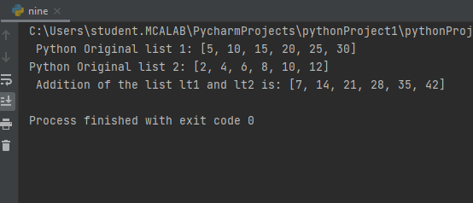

10. Write a program to find the sum of 2 matrices using nested List.
CODE:
matOne = []
print("Enter Elements for First Matrix: ")
for i in range(3):
matOne.append([])
for j in range(3):
num = int(input())
matOne[i].append(num)

matTwo = []
print("Enter Elements for Second Matrix: ")
for i in range(3):
matTwo.append([])
for j in range(3):
num = int(input())
matTwo[i].append(num)

matThree = []
for i in range(3):
matThree.append([])
for j in range(3):
matThree[i].append(matOne[i][j]+matTwo[i][j])

print("\nAddition Result of Two Given Matrix is:")
for i in range(3):
for j in range(3):
print(matThree[i][j], end=" ")
print()
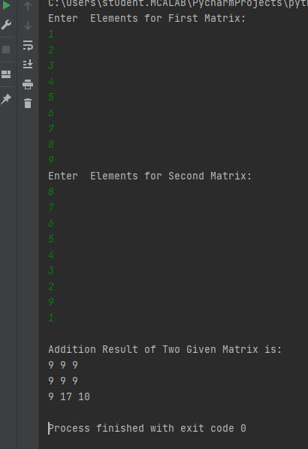

11. Write a program to perform bubble sort on a given set of elements.
CODE: # Creating a bubble sort function
def bubble_sort(list1):
# Outer loop for traverse the entire list
for i in range(0,len(list1)-1):
for j in range(len(list1)-1):
if(list1[j]>list1[j+1]):
temp = list1[j]
list1[j] = list1[j+1]
list1[j+1] = temp
return list1

list1 = [5, 3, 8, 6, 7, 2]
print("The unsorted list is: ", list1)
# Calling the bubble sort function
print("The sorted list is: ", bubble_sort(list1))
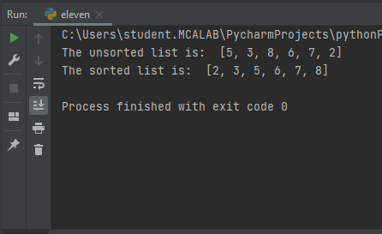

12. Program to find the count of each vowel in a string(use dictionary)
CODE:
def Check_Vow(string, vowels):

# The term "casefold" has been used to refer to a method of ignoring cases.

string = string.casefold()

count = {}.fromkeys(vowels, 0)

# To count the vowels

for character in string:

if character in count:

count[character] += 1

return count

# Driver Code

vowels = 'aeiou'

string = "Hi, I AM ASHLY JOSHY AND I AM FROM PALAI"

print (Check_Vow(string, vowels))
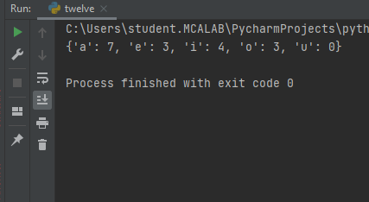

13. Write a Python program that accept a positive number and subtract from this number the sum of its digits and so on. Continues this operation until the number is
Positive
CODE:
code: def repeat_times(n):
s = 0
n_str = str(n)
while (n > 0):
n -= sum([int(i) for i in list(n_str)])
n_str = list(str(n))
s += 1
return s
print(repeat_times(9))
print(repeat_times(21))
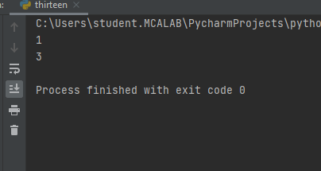
14. Write a Python program that accepts a 10 digit mobile number, and find the digitswhich are absent in a given mobile number
def absent_digits(n):
all_nums = set([0,1,2,3,4,5,6,7,8,9])
n = set([int(i) for i in n])
n = n.symmetric_difference(all_nums)
n = sorted(n)
return n
print(absent_digits([9,5,2,6,0,1,4,6,8,4]))
